Pokemon the Trading Card game

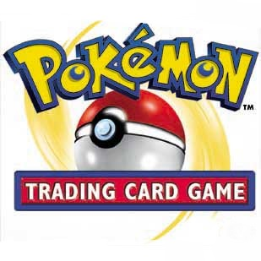
Kevin Ramos
CSC 17A
Dr Mark Lehr

Overview and Rules
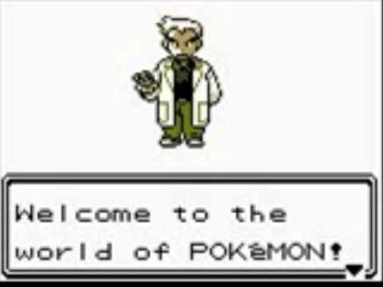

Welcome to the world of Pokemon, your journey to become a Champion of the Kanto Leauge is soon to be over; However, one more battle remain. You are tasked to oust the champion of the league in order to reclaim the title of champion yourself.
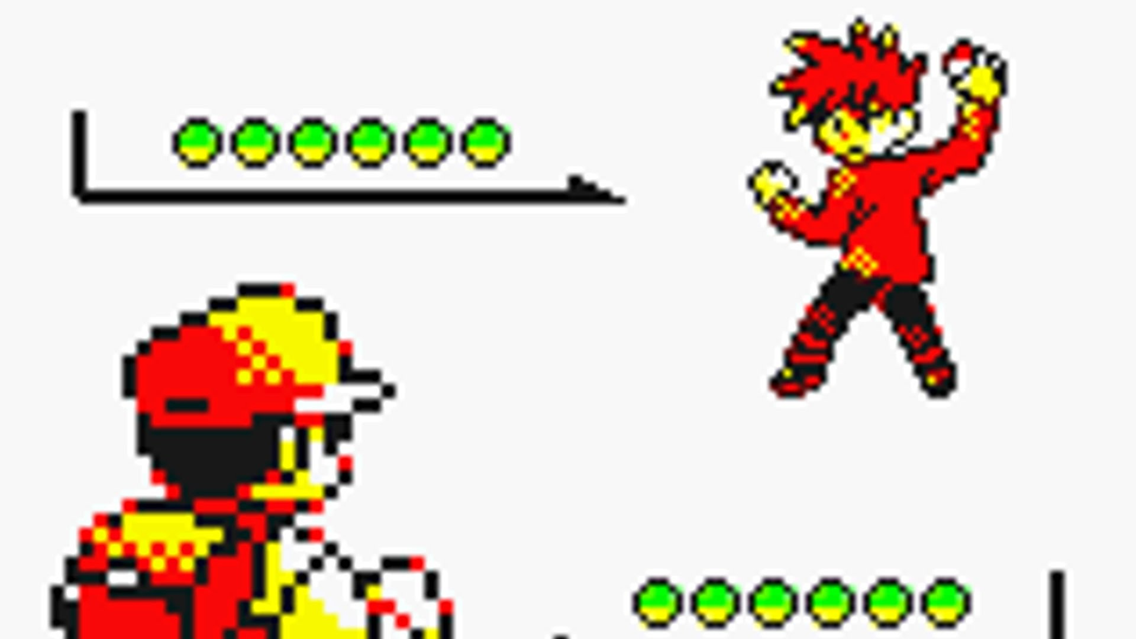

This card game consist of knocking out the enemies Pokemon. You are given 3 Pokemon cards. Each Pokemon consist of a Health Bar, 3 attack moves (which will inflict damage onto the enemies Pokemon), and the Pokemon's type.
Each Pokemon type has its own weakness, and it will be seen in the game. If a move is weak to a certain Pokemon, it deals double the damage. When a move is resistant to a certain Pokemon, it deals half that damage. Some moves like Recover and Synthesis will heal a Pokemon by 50%. The game is won once a specific team has all their health knocked down to ZERO.

Champion's Pokemon and moves:

1)Arcanine Damage taken:
Moves:
Flamethrower 40HP
Crunch 35HP
Fire Blast 50HP
HP: 110

2)Alakazam Damage taken:
Moves:
Psychic 50HP
Recover Restores 50% HP
Shadow Ball 35HP
HP:120
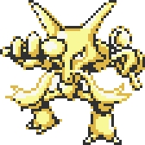

3)Blastoise
Damage taken:
Moves:
Bubble Beam 35HP
Hydro Pump 50HP
Ice Beam 45HP
HP:150
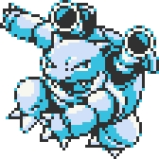
------------------------------------------------
YOUR POKEMON AND MOVES
1)Pikachu Damage Taken:
Moves:
Thunderbolt 40HP
Body Slam 30HP
Thunder 50HP
HP: 80
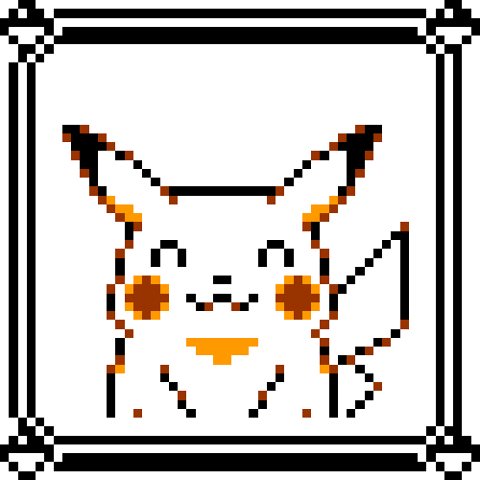
2)Charizard Damage taken:
Moves:
Flamethrower 50HP
Earthquake 40HP
Wing Attack 30HP
HP:130
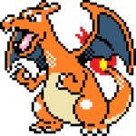
3)Venusaur Damage taken:
Moves:
Razor Leaf 45HP
Sludge Bomb 45HP
Synthesis Restores HP by 50%
HP:150


LINE COUNT INCLUDING CLASSES~=1028

